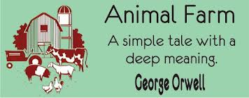

Writer’s Notebook Response:

In your mind, what would the perfect type of government be for a society? Describe it. Who would be in charge? Would everyone be considered equal? Do you believe this type of governing is possible?

