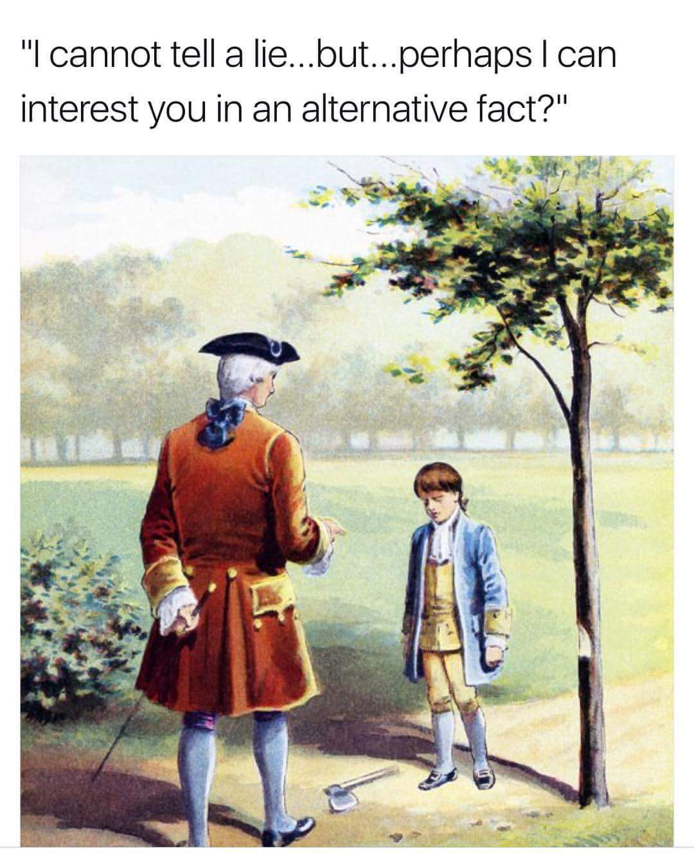
Find an “alternative fact” presented in Animal Farm by one of the characters. Quote it and explain how it is an alternative fact.

An alternative fact presented in Animal Farm is when ___________ says, “ .” This is an alternative fact because…

