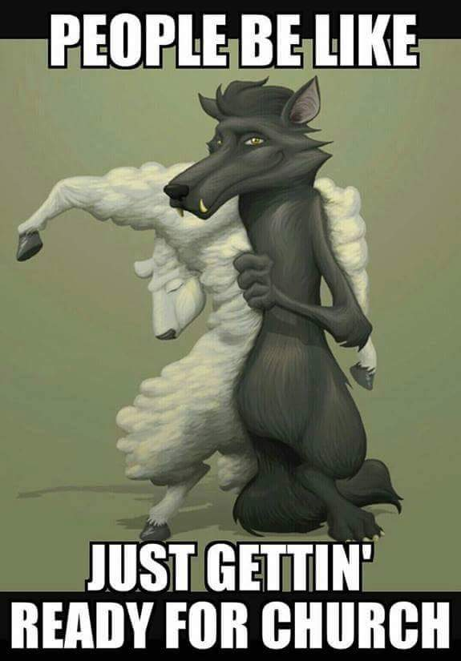

JOURNAL:
- Explain the meme above.
- How does it relate to a specific event that has unfolded in George Orwell’s Animal Farm?
- Use evidence from the text to support your answer.

