Graffiti Wall Abstract Topics to Expand Upon
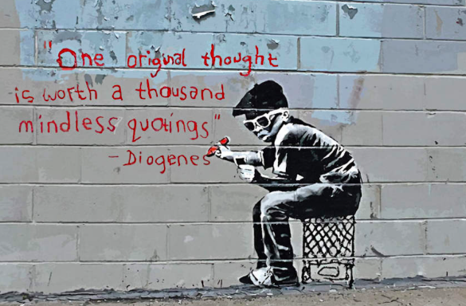

Directions: Choose 8 of the words below and come up with 2 solid examples for each from the brainstorming list given in class. If you use a personal example for love, then your second example for love must not be a personal example. It could be an example from literature, however. When you go to a new word, you may use another personal example. Writing “personal example” is not an answer. You must describe a “specific” personal or literary example, a specific historical or sports example, etc. Move from the general to the specific.

love
friendship
enmity
freedom
honesty
bravery
imagination
destiny
courage
integrity
revenge
character
beauty
perseverance
altruism

Divide 2 whole sheets of paper up into halves (8 halves total). Label the words you choose in each section. Then, put your examples in each, and within a sentence or two, elaborate on why they are an example. ie: Literary Example: Romeo and Juliet – because they are two lovers whose families do not want them to be together.

