Secondary Literacy and Language Arts
1:X iPad Integration
Writer’s Notebook, Writing Process, and Strategies
Grades 6-12

**********
The iPad offers myriad ways for student readers and writers to explore their thoughts, craft a message, and engage in every stage of the writing process. The following apps are meant as a guide to transform brainstorming, drafting, revising, and publishing, encouraging collaboration between students, peers, and teachers throughout. Students may explore these apps, or bring forward apps of their own that they find engaging. The value is always in authentic student writing, and whether a student composes on a touch screen, in a spiral notebook, composition book, or leather-bound journal, the value is in the quality of ideas students bring to their work. Students should be provided multiple options for their writing life, and encouraged to choose freely and move naturally between iPad, computer, and paper depending on their goals and purpose for writing.
Resources
iPad iTunes Apps | Examples
Writer’s Notebooks:  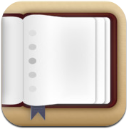  Chapters  Evernote  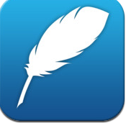  Max Journal  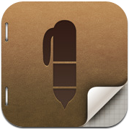  Penultimate  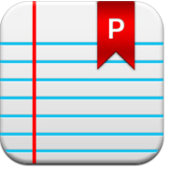  Penzu  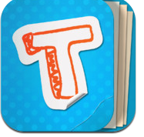  Totes m'Notes  Writing Process:  Brainstorming:  Popplet Lite  MindMeister  Grafio  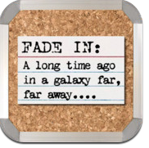  Index Card  Drafting Support:  Clean Writer  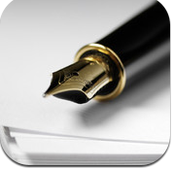  Essay Writing Guide  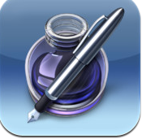  Pages  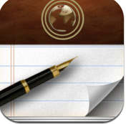  Paper Helper  Writing Poetry:  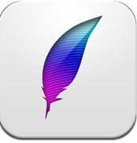  Poetreat  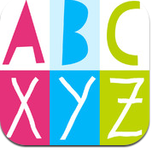  Visual Poetry  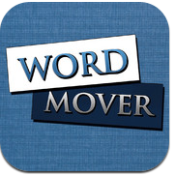  Word Mover  Writing Experiences:  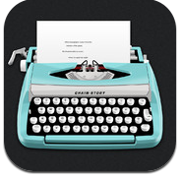  Chain Story  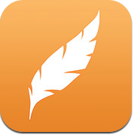  Story Up  Revision and Editing:  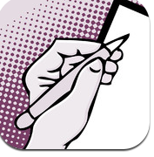  Peer Edit  i Annotate  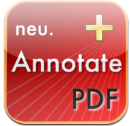  Neu Annotate  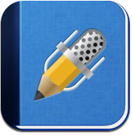  Notability  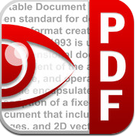  PDF Expert  Writing Prompts:  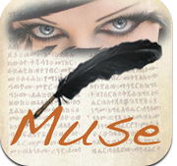  Writer's Muse Plus  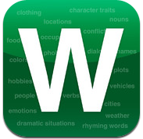  Lists for Writers  Writer's Block Buster  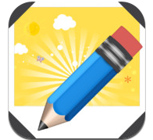  Write About This 1 | 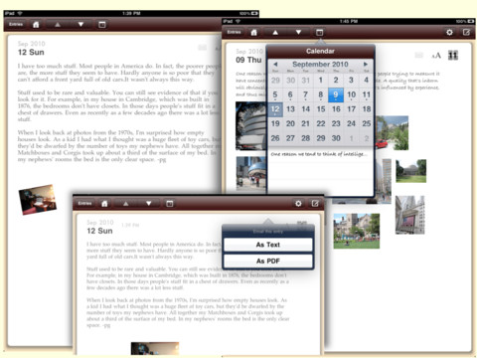  The writer’s notebook is the single most accurate formative assessment of a student’s writing development. Students should write everyday, and the work they do in class should result in a collection of practice that students revisit throughout the year. Students value their daily writings when they have the option to revise selections from their notebooks for formal writing, and use their previous work during summative assessments.  The iPad comes with a legal pad type app called Notes, which has sharing and exporting capabilities, but no real customization options. The following apps help students create various personalized notebooks. Many of them share to email and/or other social media. Some export into PDF or Word . Most of them also allow students to organize their writing inside the app in different ways, such as on shelves, and add graphics.  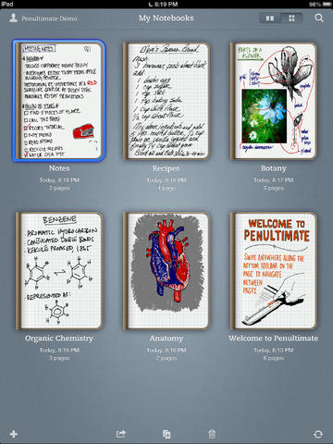  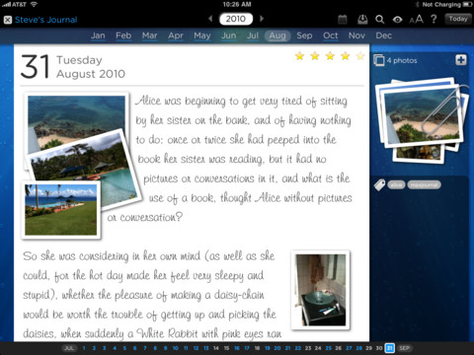  All the apps in this category provide students a canvas for brainstorming. Students can color code, determine shapes, add images, and type in text. When finished, students can save and share their work in a variety of ways. Some apps will allow for feedback and comments on the brainstorming as well.  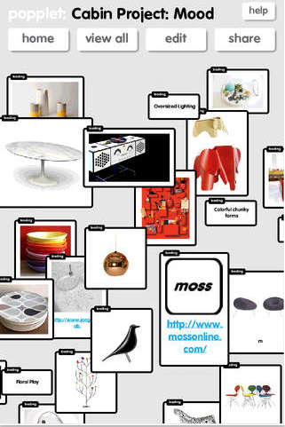  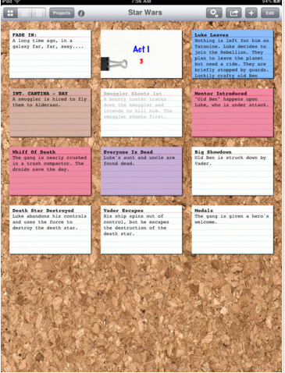  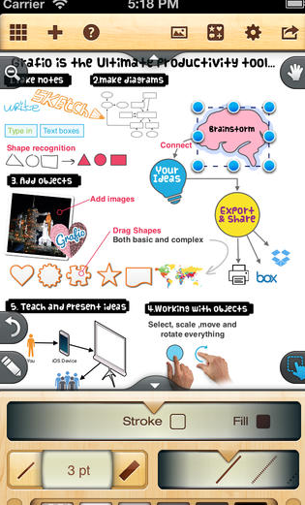  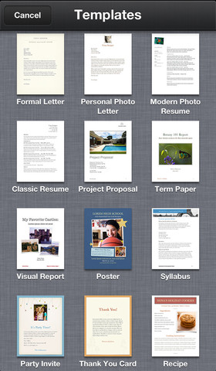  The following apps provide students with a place to create drafts of their writing. Many of them share to email and/or other options. Most of them also allow students to organize their writing inside the app in different ways, such as on shelves. Clean Writer is solely a plain text writing processor, while Pages (left) is an abbreviated version of the Mac app. Think of it as a stripped down version of MS Word. It includes templates, and can export content into .doc, .pdf, and plain text files.  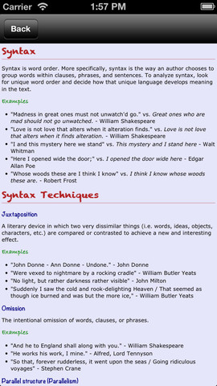  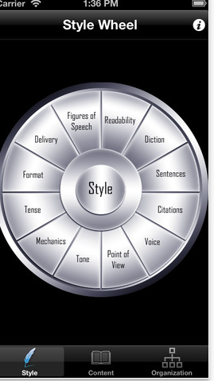  Gatsby’s Essay Writing Guide helps students with drafting a variety of essays. Using their wheels for content and style, students can explore different writing techniques and look at models from a variety of authors. Students can also read more in-depth information about certain techniques.  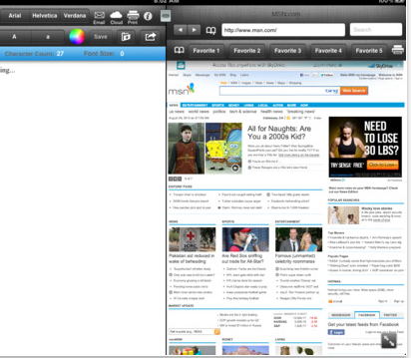  Paper Helper (below) allows students to have an internet browser sitting alongside a blank sheet. This way, students can write and incorporate their information without having to exit from one application to the next. Students can use this for research or to search for writing ideas.  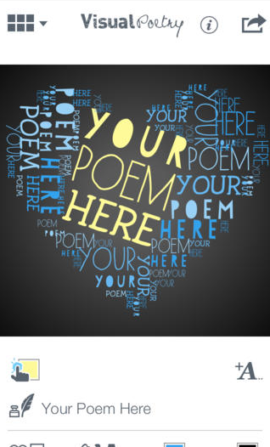  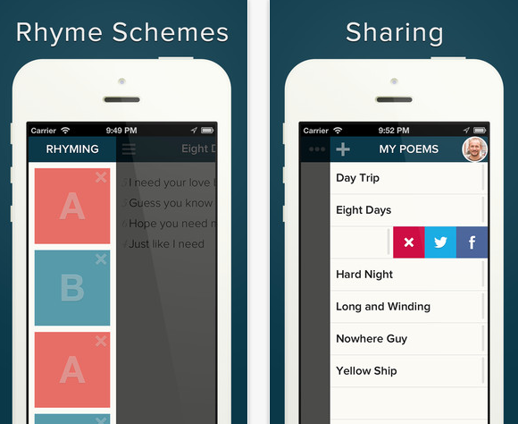  These apps help students write a variety of poems. Depending on the app, students can find help with rhyming words, collect poetry, and share poetry with others through Facebook, Twitter, and other platforms. Word Mover helps students also create found poems with various documents.  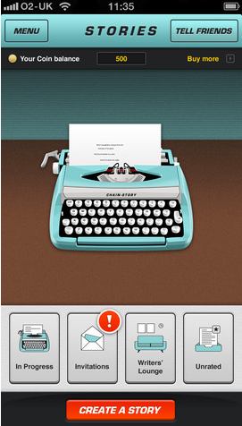  Chain story recreates the round robin style of writing where students write for a small amount of time, stop, and then pass the paper to the next person in a chain. With Chain Story, students can create longer chains and read all of the stories where they made a contribution. Students can share the finished version. Story Up operates in a similar way and has the option of keeping track of your progress through Game Center.  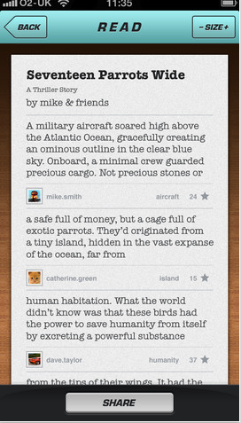  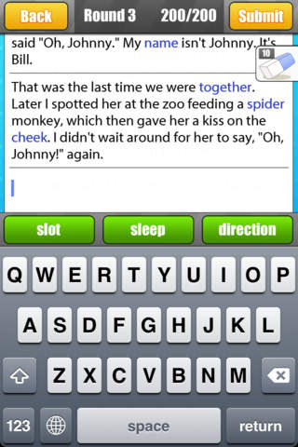  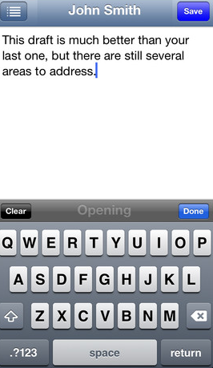  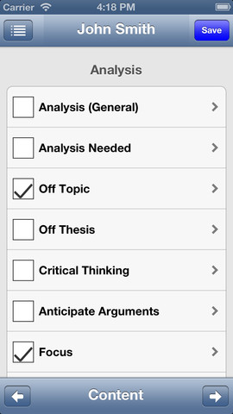  Gatsby’s Peer Edit combines editing and revision elements into this app. Students can program what they want to revise, and the peer reviewer can focus on the selected elements, comment, and send the comments back to the student. Using Peer Edit, the student can highlight issues of content and style.  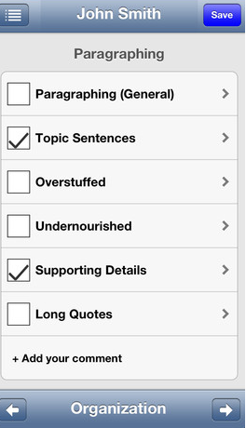  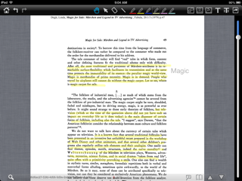  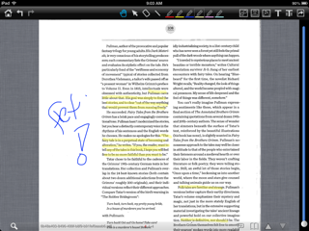  Many apps—including the .PDF apps to the side—allow users to annotate documents. For revision/editing needs, drafts can be saved as a pdf, and then opened in one of these apps. While each app has unique features, all allow the user to upload files, annotate, and send the files via email or other device like Evernote back to the user. Most apps allow annotation opportunities that include highlighting in various colors as well as writing in the margins. Some allow users to also place an image in the margin. These apps vary in terms of price, but they occasionally become free for a limited time.  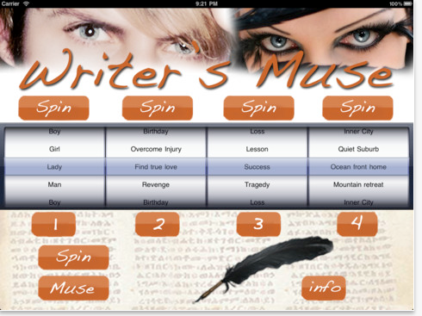  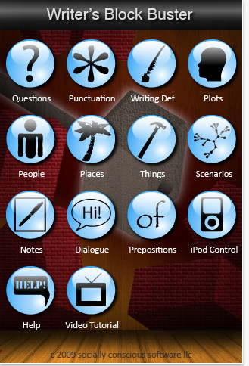  These writing prompts offer a variety of ways for students to begin a piece of writing if they find themselves stuck. While most of them lend towards narrative writing, some of them could be stretched into other genres as well. Students can add to some of the file areas on some apps and generate their own prompt ideas for later use.

